2025 MEDI6003 Summative Exam

MCQ
- 40F started on carbemazole low WBC count, high neutrophil count, now has sore throat with ulcers what is causing this? HIV, HSV stomatitis, leukemia, ?
- 18F heavy painful periods, acne, irregular periods what’s best treatment option?
- 40F with HTN managed on pril heavy periods for 1 yr what’s best treatment option? IUD, POP, COCP, mefanamic acid?
- Child gets rash after visiting friends house on trunk and back, no angioedema, what’s best treatment ? Oral pred, topical cortisol, reassure, ?
- Child has slap cheek rash, most likely cause?
- Repeat medication Q that causes muscle loss?
- Child with mediastinal mass on CXR low WBC low Hb low platelets ?
- Child with fever, urinary frequency, Ph 7.05, BE -25, cause? DKA, sepsis
- ECG atrial flutter next investigation
- ECG next investigation on b/g exertional desponea, peripheral oedema, JVP not raised
- 25 Year old aboriginal female right sternal systolic murmur radiate carotid what factor predisposed? age, rheumatic, bicuspid?
- Red swollen knee post being started on heart failure medication, what was the drug?

CST

- Joint pain post trip
- Fatigue brought in by daughter
- Abdominal pain CT image series

SAQ - 97 questions total, ~28 were PPD/PPH, rest were BCS (most stems had 2-3 questions each)
PPH/PPD

This section was pretty much repeat of past exams, dont think i saw any new questions

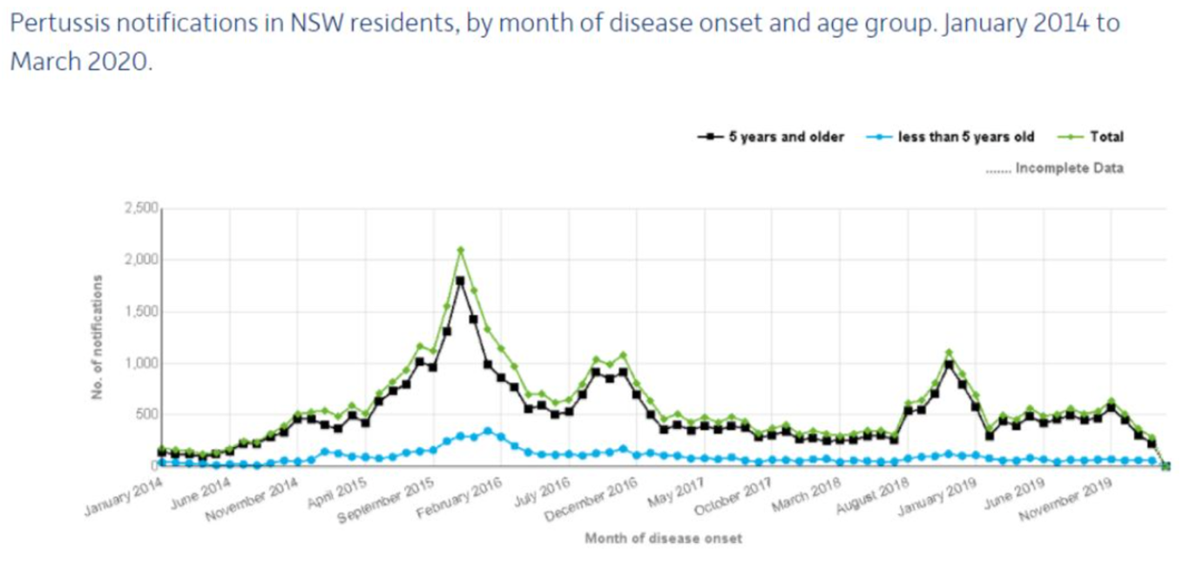

- What is the epidemiological measure that is used in this graph?
- What clinical features must be present to make the diagnosis of pertussis probable?
- What is another finding that, in addition to the probable diagnosis of pertussis (based on clinical features), would make the diagnosis of pertussis definitive?
- What changed in the pertussis vaccination schedule in 2015 for the protection of children or to improve immunity in children?
- What are 2 other changes that occurred to reduce morbidity and mortality associated with pertussis, specifically in infants less than 3 months?
- What word describes the trends that happened between August 2018 and March 2019?
- What 4 public health personal hygiene factors were implemented in 2020 that explains the reduction rates of pertussis? (with reference to COVID-19 pandemic and measures related to that)
- Absolute contraindication to pertussis vaccine

- Definition of impairment + 4 signs that a medical practitioner is impaired
- A patient comes in asking for morphine for migraine, saying previous morphine injection helped. she is distress and after hx and exam you explain to her morphine isnt the answer
  - 4 drug seeking features other than those in the stem
  - 2 strategies GP/clinic can use to stop drug misuse
- EKSD question - what is the epidemiological measure + 3 trends
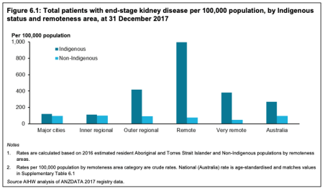

- Graph showing highest expenditure drugs from PBS, top 2 drugs were rosuvastatin and atorvastatin
  - What CV risk factor does the highest expenditure drug (rosuvastatin) address?
  - What are 4 personal preventable lifestyle factors that can reduce CVD risk and also contribute to a high disease burden?
- Shared decision making - 2 features and 4 benefits
- Mum has brought in the baby to see GP, both baby and mum have bruises, mum confirms that father hit them. Should the GP report this?
- 4 manifestations of growing up exposed to domestic violence that you may see in an adolescent/young adult?
- Mental Health Act: Involuntary admission
  - 3 things a doctor must consider about a patient before admitting
  - 4 rights of involuntary admitted patients in addition to the rights all mental health patients have
  - 2 kinds of treatment there needs to be extra consent for despite involuntary admission
- A 22 year old woman comes for a checkup at the GP after surgery. Surgery went well and there are no problems. She hasn’t seen the GP in 3 years.
  - What are 2 opportunistic preventative things the GP could do? How would the GP explain the benefit of these?

BCS

- 40 something male presenting to ED with dull chest pain and tightness. ED reg suspects acute coronary syndrome, give 6 investigations done in ED
- 36 F presenting with a week long loss of vision in the left eye, now has muscle weakness that started 2 days ago. Reduced power, left visual fields deficit, brisk reflexes but sensation intact. She had similar episode of loss of vision and muscle weakness 18 months ago that resolved spontaneously
  - whats the diagnosis
  - 2 investigations that will confirm the dx
  - 2 additional features that were not present in the case vignette
- 35 F with gallstones picked up on incidental findings when she was getting an ultrasound for unrelated condition- give 4 risk factors that are relevant to her
- 50 smth M presented with left flank pain, 3 days history of fever rigor. Urinalysis shows nitrites, blood, leukocytes.
  - Most likely dx
  - Management (4)
- 58M with type 2 diabetes presented with sudden 9/10 right groin pain. Urinalysis shows nitrites, blood, protein. Ultrasound shows hydronephrosis (something like this)
  - Dx
  - risk factors
  - Management
- 2 question with pyelonephritis picture - asked for dx, risk factors, management (above 2 qs) ((one was renal calculi the other was pyelo - there were some key differences between the questions, the pyelo question had 3 days of fevers and rigors whereas the calculi question had sudden onset 9/10 pain and hydronephrosis on the scan))
- young child with signs of meningitis, CSF analysis given - bacterial picture
  - 3 causative organisms
  - 2 antimicrobial therapy (Ceft + benpen)
- Post menopausal women - last period 5 years ago no HRT, give 6 causes of bleed
- women with spontaneous vaginal delivery - 1000 ml blood loss
  - - whats your immediate management (4 marks)
  - causes of PPH
- another post menopausal women i think, 2 kids, menarche at 13 - has a 3 cm breast lump noticed a week-ish ago, no hx of breast or any other cancer - what are her risk factors for malignant lesion
  - 6 exam findings that would indicate a lump is malignant
  - 4 extra hx you would ask
- previous exam question with obstructive jaundice picture, bilirubin was significantly raised, AST/ALT were raised but only like 10-20 above the limit, ALP was significantly raised, - no urobilinogen in urine
  - whats your dx + explain reasoning
- question on Stroke - old man with slurred speech and arm weakness - what is the key investigation to diagnose
- TIA picture - had focal neurological symptoms but resolved within 10 minutes. Bunch of exam findings - AF, carotid bruits, high cholesterol etc etc
  - what is your dx
  - What is one key investigation to diagnose
  - What’s the risk factor or cause to his diagnosis
  - what are the 2 indications in the presentation for carotid endarterectomy
- 60 something guy with COPD diagnosis 5 years ago, 3 days or 5 days history of SOB, coughing up green sputum, vitals showed he was unwell and febrile
  - whats dx
  - what are 3 investigations you need to do immediately
  - Immediate management
- another question on COPD type picture. SOB, need 2 pillow to sleep, Dry cough, back pain on inspiration?. Hx of breast cancer:
  - 4 differential Diagnosis
  - On exam: no oedema, heart nornal, stone like dullness on right lower lobe on percussion, crackles heard in RLL and wheeze through out (think this might have been breath sounds in the other q, I thought this one was reduced breath sounds in RLL), left is vesicular. Whats your most likely diagnosis?
  - Management
- previous question on guy has bipolar, manic episode 6 months ago, happy with lithium and wants to live a normal life - give 4 holistic approaches/management GP needs to discuss
- previous question of girl on psychotropic drug now has amenorrhoea/galactorrhea - 5 investigations, most likely diagnosis, how to resolve/manage it
- unwell kid with barking cough got worse at night, had a bad coughing episode yesterday that woke him up, coryzal sx, inspiratory wheeze (think this said inspiratory stridor?)
  - whats dx
  - 2 clinical features that support your diagnosis
  - management
- DKA question - ?teenager brought to hospital now admitted to ICU - 4 things in management over the next 24 hours.
- young woman with colicky abdo pain, no flatulence in the last 2 days, reduced bowel sounds on examination + other findings. Given abdo xray with small bowel significantly dilated + CT showing air fluid levels
  - asked for 3 pathological findings on imaging
  - whats the dx
- 72 year old female, 15 pack year ex-smoker, previous lumpectomy, chest pain + bunch of other things - coughing up sputum and febrile.
  - 4 ddx
  - lower zone dullness + reduced resonance, pain in left and right bases - what is your dx
    - note - i might have confused two questions together bc they were very similar
- Woman with lesions on labia - image given (no clue what that was tbh - looked like blisters to me, think this was HSV - definitely was HSV - I think it was HPV https://www.vinmec.com/eng/blog/treatment-of-genital-warts-in-many-different-locations-en the picture is in here). Asked for 5 topical/local treatments
- coeliac disease picture - 30 something women with abdo distention, diarrhoea, pain etc after she eats pasta and bread
  - Most likely dx
  - what 2 initial serology test
- 50 something guy, diagnosed with diabetes 3-4 years ago - presenting with increased fatigue over the last couple of months, increased BMI, decreased physical activity, knee arthritis takes nsaids everyday for the pain. He was a full-time carer for his wife who died recently - he never learnt how to check is BGL, no medication for diabetes
  - 4 causes of his fatigue
- young guy with appendicitis 3 benefits of laparoscopic over open surgery
- 36 week old woman with abdo pain and reduced foetal movements after trauma to abdomen. What are 4 investigations
- women gave birth thick meconium visible - child is born apgar score 5 and 7, now in NICU with resp distress. 6 features of respiratory distress
- women in early 20s, sexually active with one partner - 4 causes of post-coital bleeding
- middle aged man with hypertension, increased BMI and bunch of other risk factors for T2DM/PVD
  - 4 things exam findings specific to his presentation
  - 2 investigations to do next
- 45 year old woman with pain and stiffness in hand that is worse in the morning. She has stiffness for 90 mins, bilateral swelling of MCPs and PIPs
  - whats your diagnosis and justify
  - 2 investigations would confirm the diagnosis and what findings do you expect on them.
- 15yo kid had a mid shaft femur fracture
  - 6 complications
- Kid with knee pain, slightly flexed, unable to move, swollen, also high fever like 39 degrees or 38.8 something like that
  - Most likely dx
  - investigations
  - 2 complications if left untreated
- Mum brought in a 4 month old baby with concerns about neurodevelopmental delay. GP examines and suspects hydrocephalus - what are 4 exam findings you expect the GP to see.
- 2 Investigations to check for statin side effects
- 4 clinical features of thyrotoxicosis
- Generalised Anxiety Disorder diagnosis?, GAD vs MDD differences, GAD management
- ​​Pre-eclampsia, signs on exam, maternal complications, fetal complications

OSCE STATIONS

No combined stations like 2024, most stations were hx/exam in 7-8 mins followed by 2-3 minutes of Questions. For most stations, it said perform an appropriate history/exam (apart from cardiac and hip exam).

paeds case - new
surgical abdo - 2013, 2022
right knee pain - 2017
x
O&G - abdo pain, endometrioma and cyst - new
health discussion - 2018
x
PSYC - 2018
hip exam - 2016, 2023
x
CVS - AS - 2023, 2024
Stroke - 2022

Histories

Psych (repeat from 2018): Stem was 55 M brought in by wife for not eating/drinking for 2 days, on b/g of reduced appetite for a couple of months. Increased time spent in bed, low motivation. His GP had performed a battery of tests, including colonoscopy - all normal. Perform as appropriate hx and at 8 mins the patient will ask you a question.

Melancholic Depression vs MDE in a 55YO M with 6/12 Hx of bereavement, low mood, anhedonia, early morning waking, low appetite. Obsession/Delusion that he was going to die of bowel cancer because brother died of gastric cancer 6/12 earlier and uncle died of bowel cancer 2 years prior. No pain/FAWN sx, no changes to bowel/bladder habits- only abdo bloating
?Psychosis - no hallucinations.
?Somatoform disorder - was fixated on the fact his ‘bowel was dying’
Patient asked a question that was ‘can I go home’ - needed to pick up that he wasn’t eating or drinking so needed admission til adequate oral intake and psych review but still free to leave (not mandatory admission). I gave him a DAMA form and said good luck

GP (repeat from 2017): Underlying OA with injury making Sx more noticable. Concerned about being able to walk grandkids. Mixed OA/RA picture as morning stiffness > 1 hour that got better with movement. Some history of injury (knee was hurting and he tripped over the curb but not obvious breaks or anything). At 8 mins the patient asked what was causing his knee issue. Variability in presentation of this case. Patient was without morning pain only exertional pain (no indication of Gout or other septic arthropathy). Felt a ‘pop’ on injury [I was the third person to do this station in the Melbourne AM session and asked the patient whether they heard or felt a click, crack, or pop - they responded: no, nothing like that, it was just sore (+3 to this in Melb)] (Mechanical) and denies features of crepitus or limited ROM (in spite of 2 year chronicity) and expresses concern at the volume of ibuprofen he has been taking. Patient had +++BMI and had been working on lifestyle change for in excess of 12 months without returning for clinical review. Same imp. Mechanical on OA, but additional gen review

Paeds (new): The Stem said a mother went to the park and noticed her child had facial swelling under the eyes, and the triage blood pressure was quite hypotensive. I went in thinking it could be an anaphylaxis response in an atopic child - screened the questions, but very quickly established oliguria leading to Minimal Change Disease. (There wasn’t any preceding illness so likely idiopathic nephrotic syndrome), DDx + what POC Ix would you want? No other symptoms except for oedema and decreased urine output + frothy urine, some increase in weight (clothes were tighter) and less energetic. There was no preceding illness or any other fam/past medical hx.

OBGYN (new): 28 F Abdominal/Pelvic Pain - stem asked to take appropriate hx (?8 mins). The patient had deep, constant lower abdo pain, sudden onset 6 hours ago, 10/10 severity no radiation. No uterine discharge, not UTI sx, no diarrhoea/illness. Normal/regular menstrual cycle (LMP 2 days ago) but dyspareunia since 1 year ago. Single partner, no hx of STI/never tested.
Stopped COCP 2 years ago (conflicting info given to diff students) due to DVT. Asked to give 4 ddx. It was Right sided endometrial Cyst Endometrioma. Short term and long term management. Variation, patient also discussed short term fertility goals, wanting kids in 4 years. The assessors specifically asked about surgical intervention and pain relief in immediate management and what would contribute to long term management.

Examination

Hip (repeat from 2016, 2023): Right hip pain do a hip exam (7 mins) OA in a 60YO F. X-ray interpretation - asked for 3 pathological features (subchondral sclerosis, subchondral cysts and joint space narrowing). Then asked what features/findings on patient hx/ex would support hip replacement [I can’t remember the specific wording (I asked him to repeat the question to be sure, and I’m pretty confident he didn’t say ‘indication(s)’) I’m 99% sure it was: what factors would you need to consider to provide a THR]. Note. Position your patient with their hands on the exam table for stability (trendelenburg) - I did not and the patient fell to the ground…

Cardiac (repeat from 2023, 2024): Targeted Ex as GP referred for cardiac murmur and exertional dyspnea. Perform a targeted cardiac exam (7mins)
Only positive finding was Ejection Systolic Murmur radiating to carotids (Aortic Stenosis).
3 question:
What Ix would confirm.
Give at least 3 causes for Aortic Stenosis.
What are 3 signs that would indicate that Valvular replacement is warranted?

Surgery (repeat from 2013, 2022): Stem said lower abdo pain that progressed to RLQ pain, perform an appropriate exam (7 mins) Targeted exam, examiner reminded some students to perform a ‘focussed exam’. Ran out of things to do in the time so decided to do some fluid shift percussion because Sharon loves that.

Only positive finding - RLQ pain - peritonism.
Give 3 DDx. WHat investigations you want to do. Then asked to interpret blood Ix including -ve BhCG, raised WCC + Neutrophilia, raised CRP. Gave an ultrasound image similar to below and asked what you see - appendicitis. It had arrow disease (all gbc fans will get this)

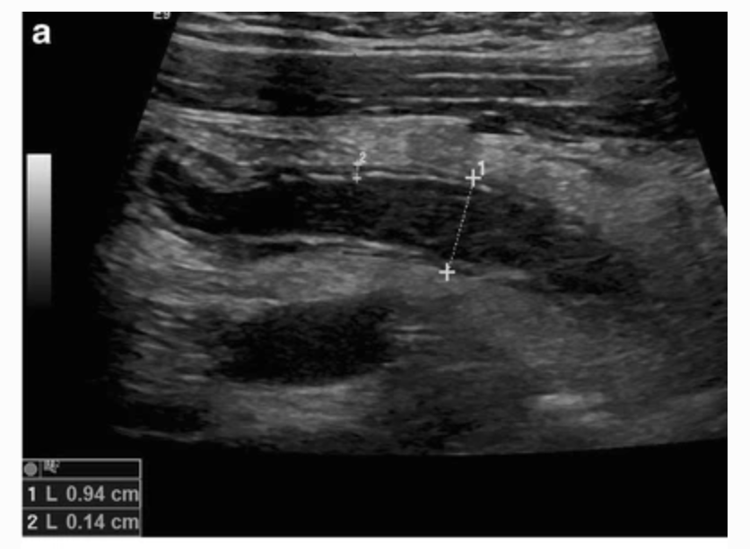

Written Interpretation

Medicine (repeat from 2018): Stem - executive health check and asked to counsel the patient on the findings and any changes/interventions needed, including pharm and non-pharm lifestyle changes.
Work Health Check - BMI 30, waist circumference was high, BP 150/70, LDL 4.8, DASS21 screening showing moderate stress, Blood Glucose 6.2, HbA1c 6.2 (prediabetic), Sedentary lifestyle, EtOH 4-6 units/day. Fam hx - mum had diabetes, dad had AMI. Variation.Patient mentioned that he was actively symptomatic on withdrawal of alcohol drinking every day at least 4-6 units of alcohol at times drinking more because of the culture at work. AUDIT-C criteria, was specifically asked by the patient (not assessor) how we would manage his detox in addition to his diet and exercise.
Variation in pt behaviour also - pt was combative with some students, wanting to leave during the consult as “feels fine there’s nothing wrong”, refusing to be referred to other health practitioners ie physio/EP/dietician. Declining any intervention for mental health etc.

Medicine (repeat from 2022) : Stem - Middle aged man with slurring words, Left ULL and LL weakness at work - sx onset at 8:30am. Given a folder outside during reading time - had more info, primary survey, neuro exam findings etc (the time on the folder was 9:45am). Given 2 mins inside the station with the same info. First task was to report to the senior registrar.
In the folder more info - left UL + LL weakness but increased tone and hyperreflexia. SBP was ~ 150, PmHx of HTN (15 years), poorly controlled T2DM. Normal FBC, CRP, normal coagulation studies, high BGL

4 questions/tasks - report to the senior registrar, give your ddx with justification. Interpret the blood results and outline initial management. Then given ECG (sinus rhythm) - red herring to see if you’d call it AF. For both the blood and ECG - the question was “what is the clinical significance” not outright asked to interpret or anything. Asked what two types of stroke were, if you didn’t give location of stroke then you would be asked this. Asked what the indications were for both hemorrhagic and ischemic stroke imaging were, what was the arch to cow trying to achieve, yes ECG, and if you had more time you were asked risk factors etc. Really lovely assessor, even if his station was in the broom closet.

